Open Access Play Registration Form
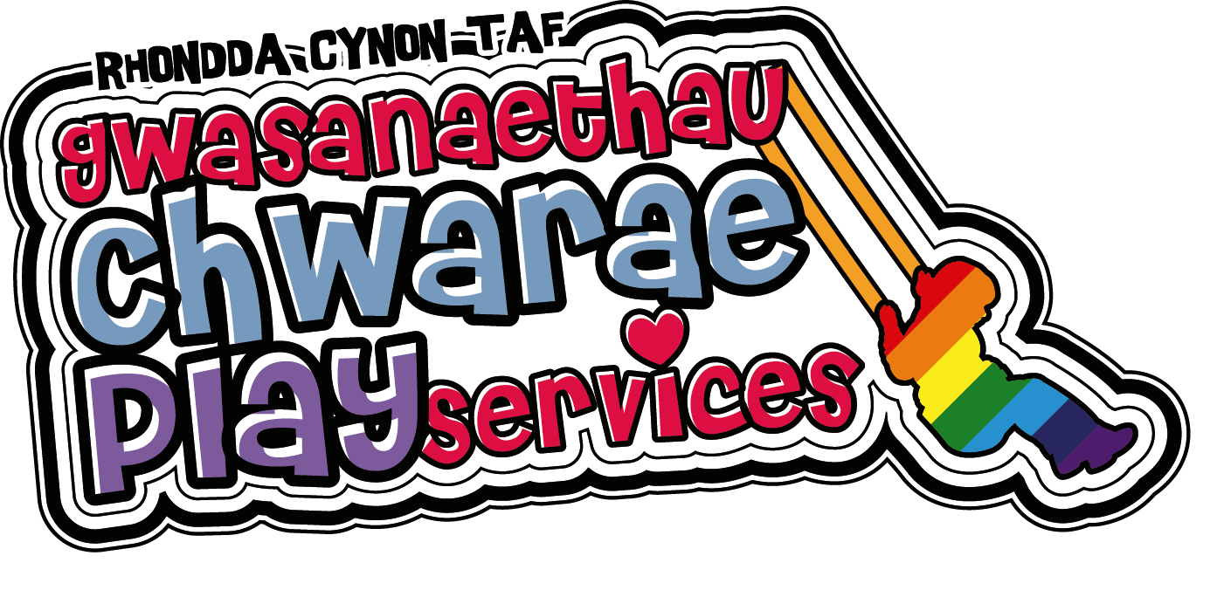
(To be completed for each individual child or young person attending Playscheme)
The following information is required to register your child and to ensure your child’s safety. For more information on how we process and protect your information please contact us directly by email rhydyfelin@little-inspirations.co.uk

Name of Playscheme | Little Inspirations Open Access Rhydyfelin
Name of Child

Home Address

Date of Birth | Age | Gender

Emergency Contact Details
Name | Telephone Number
Relationship to the Child | Address
Name | Telephone Number
Relationship to the Child | Address

Medical and Dietary
- Does your child have any medical conditions that may affect them during the play session?  If yes please give details; ____________________________________________  _________________________________________________________________ | YES / NO
- Does your child have a disability or specific care need?  If yes please give details;____________________________________________  ________________________________________________________________  c)Does your child have any special dietary requirements or allergies; including any type of non-prescription medication?  If yes please give details; ____________________________________________  _________________________________________________________________ | YES / NO
 | YES / NO

First Aid and Medical Treatment
- I give permission for a qualified first aider to provide First Aid to my child should he/she have a minor accident: | YES / NO
- I give permission for my child to wear plasters: | YES /NO
- I give permission for my child to receive emergency medical treatment by medical professionals in the event of an emergency: | YES / NO
- I understand that every effort will be made to contact me or another person named as the emergency contact should the need arise: | YES / NO

Photo / Imagery / video
- I give permission for my child to be photographed / videoed, which may include being used for displays within and out of the setting. | YES / NO
- I consent to Play Services (RCTCBC) using my child’s imagery / video footage for future promotional purposes on outdoor media, Council Websites, Council social media accounts, Council digital and print publication. | YES /NO
- I consent to Play Services (RCTCBC) sharing my child’s imagery / video footage with local and/or national media. | YES / NO
(Please be advised you can change your mind at any time about your child being in an image / video. If you do change your mind, please speak to the Play Leader.)
DECLARATION
It is ESSENTIAL that this section is completed.
I understand that my child or young person (CYP) will always be supervised during the play session and understand that this is an open access play session, which means my CYP, is free to leave at any time and that the play staff are not responsible for my CYP once he/she has left the session. | YES / NO
I understand that, by law we are required to follow the correct all Wales safeguarding procedures with regards to any safeguarding concerns we may have for children & young people who attend our play provision. This means that as part of our professional duty we may be required to submit a C1, which will contain detailed information regarding our concern for your child’s safety and wellbeing, to the Cwm-Taf-Morgannwg Multi Agency Safeguarding Hub. To avoid any misunderstanding, please be advised you MUST inform staff at the start of each session of any marks, bruises and/or injuries your child has. | YES / NO

Signed _____________________________________________ Date_________________________
Relationship to the child__________________________________________________________
As Parent/Carer I understand that it is my responsibility to:
- Fully complete all registration paperwork issued by my provider prior to my child starting at that setting.
- Ensure that a responsible adult will always be available via telephone during the session.
- Ensure that my child is collected promptly at the end of each session (if being collected by an adult)
- If after a significant period of non-attendance, I will be required to complete a new registration form as the contact details may be out of date.

- I have read the parent/carer responsibilities and agree to adhere to the protocol highlighted above.
- Full risk assessments for all activities are available on request.

I consent to my information being shared with the Play Development Team. | Yes / NO
I am aware of and consent to information contained within this form (and any attachments) being shared appropriately and securely to identified partners working with Rhondda Cynon Taf County Borough Council. | Yes /NO
I agree to the Play Development Team contacting the following service areas if additional information is required:  - Youth Engagement and Participation Services  - Occupational Therapy Service  - Disabled Children’s Team  - Resilient Families Service  This additional information will only be requested if it is required to support the placement of the child accessing the Service. | Yes/NO  Yes/NO  Yes/NO

The personal details we require are your name, contact details such as email address or telephone number and the time and date you visited our premises. This information will be kept for a period of 21 days from the date of your visit.
For more information on how your personal information will be used by the Councils please visit www.rctcbc.gov.uk/dataprotection.

Signed _____________________________________________ Date_________________________
Relationship to the child____________________________________________________________

Oral Medication Permission Form
(One form MUST be completed each day for any oral medication required)
To be completed and administered by a designated member of staff
Medication
Name of medication, as shown on the package ___________________________________________
__________________________________________________________________________________
Dose ___________________
Method of administration \ (e.g. oral tablet, inhaler, epi pen) ______________________________
_________________________________________________________________________________
Date ____________________________ Time given ________________________________
Expiry date ______________________ Batch Number ____________________________
Storage of medication ______________________________________________________________
Administered or supervised by (full name) ______________________________________________
Signed ___________________________________ Date ______________________________
Witnessed by (full name) ____________________________________________________________
Signed ____________________________________ Date _______________________________

To be completed by the CYP parent / guardian at the end of the session.
Name: | Relationship to the CYP:
Signature: | Date:

